Distributed Systems Project Report

Title:
Distributed Microservice Health Monitoring System

Team No: 9
Subject Code: 23CSE312
Subject: Distributed Systems

S.No | Reg No | Name | Section
1. | BL.EN.U4CSE23130 | K.L.Anvitha | CSE B
2. | BL.EN.U4CSE23141 | P. Pavitra Kumari | CSE B
3. | BL.EN.U4CSE23132 | M. Sai Meghana | CSE B

I. Problem Statement:
Modern distributed systems consist of multiple microservices whose performance and reliability must be continuously monitored. Traditional centralized monitoring systems suffer from issues like single point of failure, limited scalability, and lack of real-time insights. This makes it difficult to detect service failures and performance issues efficiently. Therefore, a distributed monitoring solution is required to ensure fault tolerance, high availability, and real-time tracking of system health.
II. Introduction:
Distributed systems based on microservices architecture are widely used for building scalable and flexible applications. However, monitoring multiple independent services is complex and requires efficient tracking of system performance and availability. This project presents a Distributed Microservice Health Monitoring System that uses Python and Flask to monitor services in real time, ensuring fault tolerance, quick failure detection, and improved system reliability.
III. Literature Review:
Recent research in distributed systems emphasizes the adoption of microservices architecture for building scalable and flexible applications. Works such as Building Microservices by Sam Newman and studies comparing monolithic and microservices architectures highlight the benefits of modular design, independent deployment, and improved scalability. Other research explores the evolution of microservices and the challenges involved in migrating from traditional systems, particularly focusing on maintaining system stability and managing inter-service communication effectively.
Further studies focus on monitoring, DevOps practices, and cloud-native systems, emphasizing continuous integration, performance benchmarking, and system reliability. Research also identifies key challenges such as real-time monitoring, efficient alert generation, fault tolerance, and automatic recovery in distributed environments. These limitations indicate the need for improved monitoring solutions, which motivates the development of a distributed health monitoring system capable of detecting failures and performance issues efficiently.
IV. Methodology:
4.1 System Architecture:
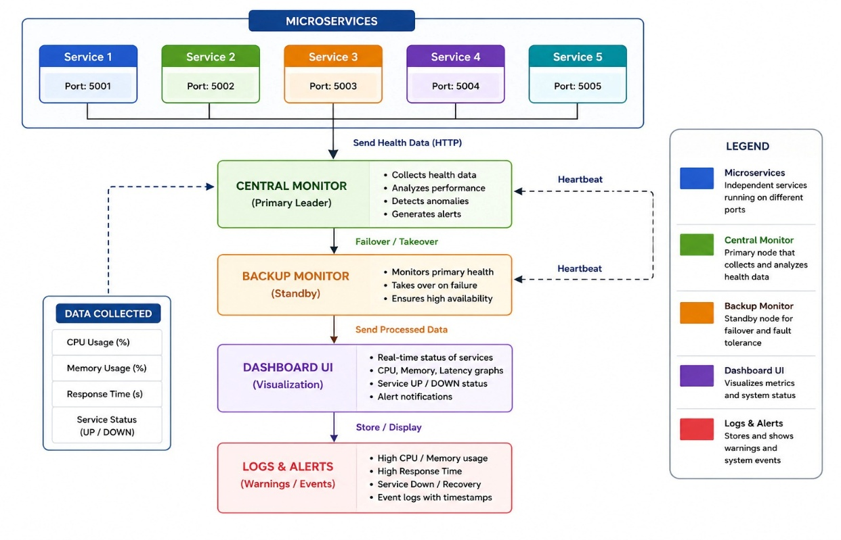
4.2 Design Explanation and Layered Analysis:
The system is partitioned into four distinct functional layers to ensure modularity:
Microservice Layer: Consists of multiple independent microservices running as separate processes. Each service performs its own task and exposes health-related data such as CPU usage, memory usage, and response time through APIs.
Monitoring Layer (Primary Monitor): Acts as the central monitoring unit that collects health metrics from all microservices using HTTP requests. It analyzes system performance, tracks service status, and detects failures using a heartbeat mechanism.
Fault Tolerance Layer (Backup Monitor): Functions as a secondary monitoring system that automatically takes over if the primary monitor fails. This ensures continuous monitoring and eliminates the single point of failure in the system.
Visualization Layer (Dashboard): Provides a user interface built using HTML and CSS to display real-time system status. It shows service availability (UP/DOWN), performance metrics, and graphical representations of system behavior.
4.3 Identified Architectural Flaws:
The system has limitations in scalability and efficiency, as the central monitor collects data from all microservices, which can create performance bottlenecks as the system grows. This introduces partial dependency on the monitor and increases network overhead due to continuous HTTP communication, affecting real-time performance.
Additionally, the fault detection and recovery mechanism is basic. The backup monitor may not provide seamless failover, leading to temporary monitoring gaps. The system relies on simple threshold-based alerts and lacks advanced features like intelligent anomaly detection, automated recovery, and persistent data storage, limiting its effectiveness in large-scale environments.

V. Results:
5.1 Current System Achievements:
• Real-Time Monitoring: Successfully monitors multiple microservices simultaneously and tracks CPU usage, memory usage, and response time.
• Fault Tolerance: Implementation of a backup monitor ensures continuous monitoring and eliminates single point of failure.
• Service Health Detection: Heartbeat mechanism effectively identifies service status (UP/DOWN) and detects performance degradation.

5.2 Root Causes of System Limitations :
Technical analysis of the system identified the following key limitations:
Central Monitor Dependency: The system relies heavily on the central monitor, which can become a bottleneck as the number of services increases.
Network Overhead: Continuous HTTP communication between services and the monitor introduces latency and affects real-time performance.

